|  |  |
| --- | --- |
| \\VFILERDPI\DPI-Home\OBRIENR2\My Documents\Downloads\PP logo.jpg |  |
| **COUNCIL ASSESSMENT REPORT**  HUNTER AND CENTRAL COAST PLANNING PANEL | |

|  |  |
| --- | --- |
| PANEL REFERENCE & DA NUMBER | PPSHCC-110  DA/3015/2021 |
| PROPOSAL | Road (Fernleigh track extension, Belmont) |
| ADDRESS | 34 Alick Street, 50C Alick Street, 11 Brandt Close, 12 Andra Close, 1A Andra Close BELMONT NSW 2280,  7A Ocean Park Road and 36 Ellen Street BELMONT SOUTH NSW 2280  Lot 101 DP 1263047, Lot 802 DP 1066865, Lot 82 DP 733198, Lot 35 DP 253148, Lot 36 DP 253148, Lot 4 DP 556338, Lot 1 DP 553216 |
| APPLICANT | Lake Macquarie City Council |
| OWNER | All lots are owned by Lake Macquarie City Council |
| DA LODGEMENT DATE | 10 December 2021 |
| APPLICATION TYPE | Development Application (Designated Development) |
| REGIONALLY SIGNIFICANT CRITERIA | Clause 3(b), Schedule 7 of the Planning Systems SEPP: Council development in excess of $5mil CIV |
| CIV | $5,654,000.00 |
| CLAUSE 4.6 REQUESTS | Submitted – Variation to height development standard (Clause 4.3 of the Lake Macquarie Local Environmental Plan 2014). |
| KEY SEPP/LEP | * *State Environmental Planning Policy (Resilience and Hazards) 2021 (Previously SEPP No. 33 - Hazardous and Offensive Development & Coastal Management)* * *State Environmental Planning Policy (Planning Systems) 2021(previously SEPP State and Regional Development 2011)* * *Lake Macquarie Local Environmental Plan 2014* * *Lake Macquarie Development Control Plan 2014* |
| TOTAL & UNIQUE SUBMISSIONS KEY ISSUES IN SUBMISSIONS | The application was publicly notified to adjoining landowners for the following period:   * 7 December 2021 – 19 January 2022; and * 3 August 2022 – 24 August 2022   Council received two objections in relation to the proposal from the first round of notification.   * The submissions generally pertain to: * Suitability of access locations; * Traffic impact and safety; * Proximity of the track to residences; and * Potential environmental impacts.   No submissions were received in response to the second round of notification. |
| DOCUMENTS SUBMITTED FOR CONSIDERATION | **Plans**  Concept Plan Set  **Reports and documentation**  Environmental Impact Assessment  Aboriginal and Cultural Heritage Report  Soil and Water Management Plan  Noise Impact Assessment  Limited Site Investigation  Biodiversity Development Assessment Report  Crime Risk Assessment  Traffic Impact Assessment  Visual Impact Assessment  Geotechnical Investigation  **Attachments**  Appendix A - SEARS report  Appendix B - Draft conditions of consent |
| SPECIAL INFRASTRUCTURE CONTRIBUTIONS (S7.24) | N/A |
| RECOMMENDATION | Approval, subject to conditions of consent |
| DRAFT CONDITIONS TO APPLICANT | Yes |
| SCHEDULED MEETING DATE | 13 October 2022 |
| PREPARED BY | Jonathan Ford – Senior Development Planner |
| DATE OF REPORT | 5 October 2022 |

**EXECUTIVE SUMMARY**

Lake Macquarie City Council is seeking development consent for a 1.5km portion of the Fernleigh Awabakal Shared Track adjacent to Belmont lagoon, including a bridge, viewing platform and a public artwork installation. The development forms part of a broader Council project for a 27 km shared pathway from Newcastle to southern Lake Macquarie.

The proposal is designated development due to proximity to the adjacent wetland, and is within the Regional Planning Panel’s delegation as it comprises Council works in excess of $5mil.

Integrated referrals were sent to NSW Fisheries and the Natural Resource Access Regulator. There referrals were rejected as the agencies indicated their comments were sufficiently addressed during pre-lodgement consultation.

Key assessment items include:

* Ecology and waterway impact;
* Social impacts, noise and crime risk;
* Flooding, bushfire and emergency procedures;
* Aboriginal and European heritage;
* Scenic amenity and visual impacts;
* Land contamination and remediation.

The applicant has submitted comprehensive documentation demonstrating due consideration of the above matters.

The principles of avoidance, minimisation and mitigation have been applied to reduce impacts on native vegetation and habitat. Biodiversity offset credits are to be retired for unavoidable direct and indirect ecological impacts.

The proposal was notified from 7 December 2021 – 19 January 2022 and 3 August 2022 – 24 August 2022. Two submissions were received in response to the first round of notification. No submissions were received in response to the second round.

The project demonstrates consistency with matters for consideration under Section 4.15 of the *Environmental Planning and Assessment Act* 1979, as well as Council’s Community Strategic Plan.

The application is recommended for conditional approval.

1. **THE SITE AND LOCALITY**

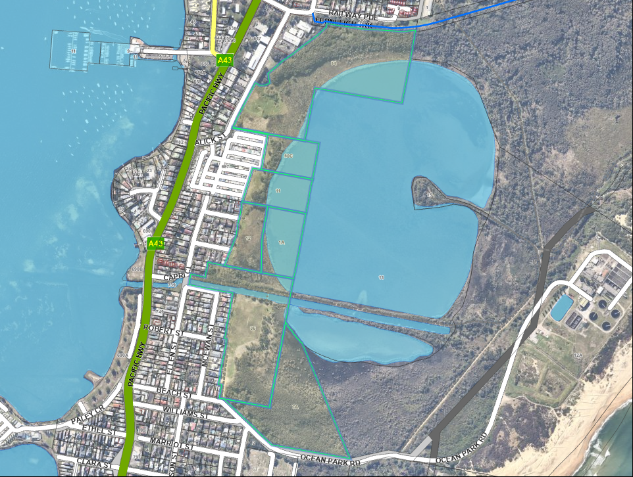The site is comprised of seven lots fronting a large saltwater lagoon in southern Belmont.

**Figure 1 – Aerial view of lots forming subject site**

Most components of the overall track project are being undertaken as development permitted without consent in accordance with Part 5 of the *Environmental Planning and Assessment Act* 1979. The provisions of *State Environmental Planning Policy (Resilience and Hazards)* 2021 specify that development consent is required for proposals involving clearance of marine vegetation within coastal wetlands. The subject application pertains to the sections of the pathway that are within or immediately proximate to a coastal wetland (Belmont Lagoon).

Surrounding development is comprised of residential land uses to the west and south, vegetated environmental land and the lagoon to the east and the Belmont town centre to the north. Points of interest proximate to the track include Glendale TAFE at the northern end, a seniors living complex south of the TAFE of Alick Street and a Hunter Water treatment facility east of the lagoon.

The track crosses Cold Tea Creek at its southern end, a man-made waterway with some heritage significance.

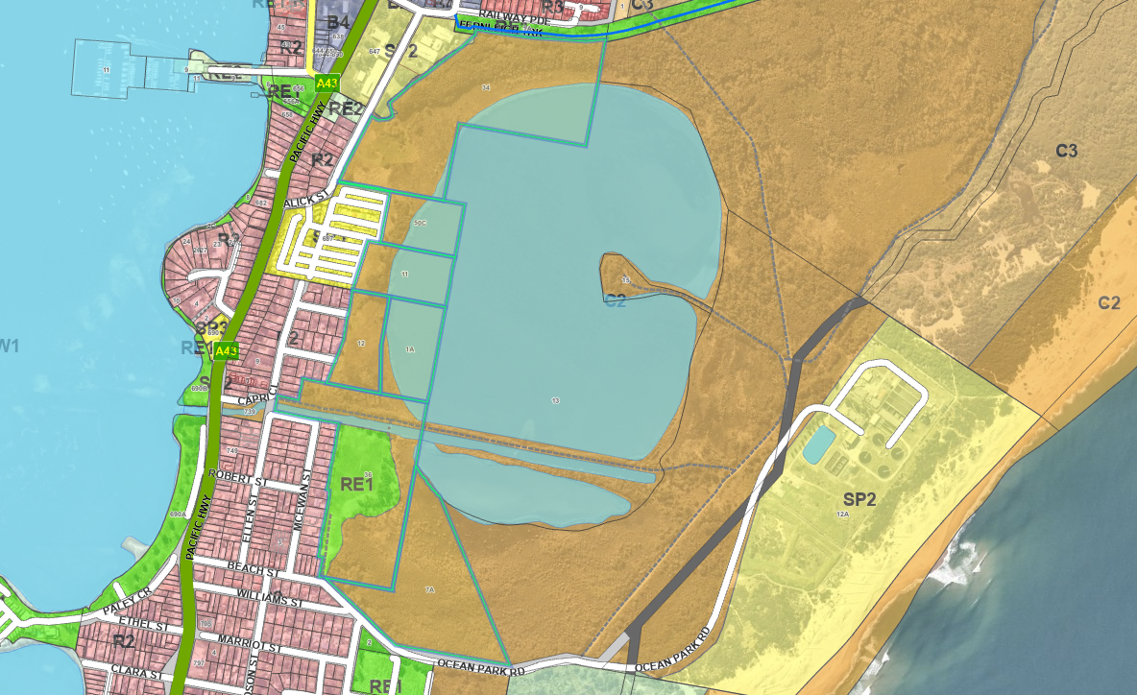

**Figure 2 - Zoning map**

The site is split zoned, comprising C2 (Environmental Conservation) for the majority of the development area. The track will also cross small areas of SP2 (Infrastructure) and RE1 (Public Recreation).

1. **THE PROPOSAL AND BACKGROUND**
   1. **The proposal**

The proposal comprises 1.5km of shared pathway as well as a bridge, viewing platform and a public artwork installation. Ancillary works including clearing, earthworks and site rehabilitation are also proposed.

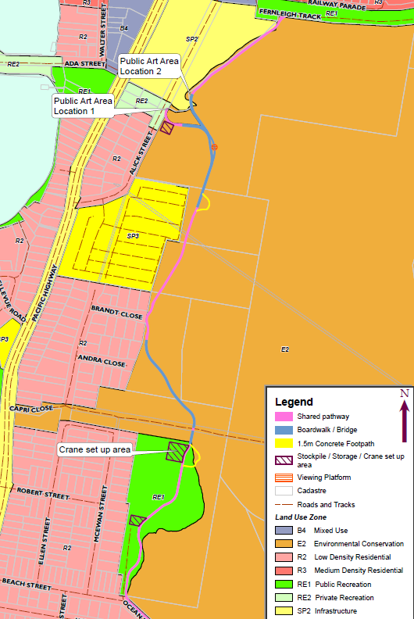

**Figure 3 - Extract from EIS showing proposal extent**

The shared pathway comprises a mixture of concrete footpath and piered boardwalk. Boardwalk is proposed to minimise construction and ongoing impacts over wetland areas within the site. The path width is variable between 3-4.5m, with 1.5m ‘offshoot’ corridors provided for viewing the lagoon.

An elevated viewing platform is proposed at the northern end of the track east of the TAFE, and a new bridge is proposed to replace the existing crossing at Cold Tea Creek. The design for both the viewing platform and bridge have been informed by the Awabakal dreaming story of Belmont lagoon, per consultation with local aboriginal groups.

* 1. **Background**

The application was lodged on 10 December 2021.

A chronology of the development application since lodgement is outlined in Table 1.

**Table 1: Chronology of DA**

| Date | Event |
| --- | --- |
| 10 December 2021 | DA lodged |
| 7 December 2021 – 19 January 2022 | Exhibition of the application |
| 16 February 2022 | Kick-off briefing with Panel |
| 12 May 2022 | Site inspection briefing with Panel |
| 25 May 2022 | Information request issued to applicant |
| 3 August 2022 | Applicant response to information request received |
| 3 August 2022 – 24 August 2022 | Re-exhibition of the notification |
| 15 September 2022 | RPP Assessment update briefing |

1. **STATUTORY CONSIDERATIONS**

Assessment against matters arising from Section 4.15 of the *EP&A Act* is provided below. Where a specific control, instrument or plan is not listed, it has been considered and deemed not relevant or of minor / inconsequential impact.

* 1. **Designated development**

The proposal is Designated Development under Chapter 2 of State Environmental Planning Policy (Resilience and Hazards) 2021, being development comprising works on land within a coastal wetland.

The applicant obtained the NSW Secretary’s Environmental Assessment Requirements (SEARs), and submitted an Environmental Impact Assessment accordingly. The development displays appropriate consideration of the matters provided in the SEARs, as detailed by the assessment summary at Appendix **A**.

* 1. **Integrated development**

The application was nominated as integrated development with respect to the below agencies:

**Table 2: Integrated referrals**

|  |  |  |
| --- | --- | --- |
| **Agency** | **Act & Provision** | **Approval Required** |
| NSW Department of Primary Industries | *Fisheries Management Act 1994* | s205  *Permit to cut, remove, damage or destroy marine vegetation on public water land or an aquaculture lease, or on the foreshore of any such land or lease* |
| Natural Resources Access Regulator | *Water Management Act 2000* | s91  *Activity Approval and Aquifer Interference:*  *Controlled Activity – confers a right on its holder to carry out a specified controlled activity at a specified location in, on or under waterfront land* |

Both agencies rejected the integrated referrals for further comment. Correspondence was obtained from the referral bodies indicating that the applicant had satisfied their requirements through preliminary consultation while addressing the Secretary’s Environmental Assessment Requirements.

* 1. **Section 4.15(1)(a)(i) - Provisions of Environmental Planning Instruments**

The following Environmental Planning Instruments (EPIs) are relevant to this application:

* *State Environmental Planning Policy (Planning Systems) 2021*
* *State Environmental Planning Policy (Infrastructure) 2007*
* *State Environmental Planning Policy (Vegetation in Non-Rural Areas) 2017*
* *State Environmental Planning Policy (Resilience and Hazards) 2021*
* *State Environmental Planning Policy No. 44 – Koala Habitat Protection*
* *State Environmental Planning Policy (Industry and Employment) 2021*
* *Lake Macquarie Local Environmental Plan 2014*

*Note: A suite of amendments were undertaken to most existing State Environmental Planning Policies after lodgement of the subject application. Given no savings or transitional provisions apply, consideration under the new SEPPs is provided. It is acknowledged that most provisions in the SEPPs applicable to the development are substantially the same.*

Alignment of the proposal with applicable EPIs is outlined below.

**State Environmental Planning Policy (Industry and Employment) 2021**

**Chapter 3 – Advertising and Signage**

Proposed signage is considered to align with the definition of ‘community notice and public information signs’ under State Environmental Planning Policy (Exempt and Complying Development Codes) 2008.

Accordingly, the signage is exempt and does not require consideration under the signage provisions of the Industry and Employment SEPP.

**State Environmental Planning Policy (Planning Systems) 2021**

The development is categorised as regionally significant development in accordance with Schedule 6:

* + Council related development over $5 mil

Accordingly, the development is to be determined by the Hunter and Central Coast Regional Planning Panel.

**State Environmental Planning Policy (Resilience and Hazards) 2021**

**Chapter 2 – Coastal Management**

The majority of the proposed development is within area mapped as Coastal Wetland under the Reslience and Hazards SEPP (RH SEPP).

Provisions that disempower Council to undertake the work as work ‘permitted without consent’ are provided under the Coastal Management chapter, as follows:

* + Clause 2.5 of the RH SEPP specifies that it prevails over any other EPI to extent of any inconsistency;
  + Clause 2.7 (1) provides that earthworks, vegetation clearing and harming of marine vegetation may only be carried out in the coastal zone with development consent;
  + 2.7 (2) categorises development requiring consent under subclause (1) to be designated development.

The coastal zone applies to almost the entire development area. Small areas where the pathway deviates outside of the mapped coastal zone are considered ancillary to the overall development and therefore comprise part of the subject application.

Clause 2.7 (4) provides that the consent authority must be satisfied that sufficient measures have been, or will be, taken to protect, and where possible enhance, the biophysical, hydrological and ecological integrity of the coastal wetland or littoral rainforest.

An assessment of the likely impacts to coastal wetlands in accordance with the SEPP have been provided within the Environmental Impact Statement, noting:

* + 0.6ha of clearance in the coastal wetland and proximity area;
  + 0.63ha clearance of exotic / weedy vegetation.

The design and route of the path minimises impacts on the wetland. Piered boardwalk construction is proposed over sensitive wetland areas to minimise land disturbance.

Portions of the development also fall within the Coastal Vulnerability Area and Coastal Use area per Sections 2.9 and 2.10 of the RH SEPP respectively. In response to the matters for consideration provided under these Clauses, it is noted:

* + The development design has evolved from substantial consultation and feedback from local aboriginal groups;
  + Ecological impacts have been appropriately managed as detailed by the applicant’s ecological assessment;
  + Public access to foreshore areas will be enhanced by the proposal;
  + Resilience to coastal hazards and flooding has been integrated into the development design. The pathway and associated works are capable of withstanding inundation in the event of flooding. Where elements of the development are below Council’s flood planning level, signage is to be provided to indicate the area may be subject to flooding.

Overall the development is considered to satisfactorily address relevant matters under Chapter 2 of the RH SEPP.

**Chapter 4 – Remediation of Land**

A phase 1 contamination assessment has been prepared for the development, comprising a desktop review and shallow soil sampling. The assessment provided the following observations:

* Potential sources of contamination identified during the desktop include uncontrolled fill opposite 31-35 Alick Street and illegal fly tipping;
* Asbestos fragments were discovered in isolated areas of the site;
* Laboratory analysis did not indicate soil contamination exceeds human health criteria.

The assessment concludes that the site is considered suitable for the proposed use with the exception of the asbestos discovered within the site area. Consequently, the report recommends the imposition of the following conditions:

* Preparation of an asbestos management plan detailing procedures for the removal of asbestos containing material in the site area;
* A general condition for unexpected finds.

Conditions to the above effect have been drafted, hence the development is considered satisfactory with regard to land contamination.

**State Environmental Planning Policy (Vegetation Non-Rural Areas) 2017**

This SEPP applies the state biodiversity offset scheme to developments that do not require development consent, and is hence not applicable to this proposal.

**State Environmental Planning Policy (Biodiversity and Conservation) 2021**

**Chapter 3 – Koala Habitat Protection**

The submitted BDAR has assessed the likelihood of Koalas and Koala habitat within the proposed works area in accordance with the requirements of this SEPP. Conclusions of the SEPP assessment are supported and no further consideration of this SEPP is required.

**Chapter 6 – Bushland in Urban Areas**

The SEPP applies to bushland in areas zoned for public open space areas. Portions of the development site are zoned RE1 – Public Recreation. Clause 6.5 provides that the extent and reasonableness of any clearance must be considered before consent can be granted. As previously outlined, the environmental impacts of the development have been minimised. The development is consistent with requirements arising from Chapter 6.

**Lake Macquarie Local Environmental Plan 2014**

**Part 1 – Preliminary**

**1.9A Suspension of covenants, agreements or instruments**

Portions of the land are subject to restrictive covenants and agreements. The applicant was requested to obtain the terms of these covenants and confirm compliance therewith.

The majority of the restrictions are not applicable to the proposal, relating mainly to reservation by the Crown for mines and minerals.

The investigation did demonstrate the track crosses two 3m wide drainage easements, displayed on updated plans. Given the nature of the works they are not considered to interfere with the operation or purpose of these easements.

Easements for Hunter Water infrastructure was also identified proximate to 11 Brandt Close and 36 Ellen Street. The updated plans submitted by the applicant have been endorsed by Hunter Water.

A condition requiring adherence to Hunter Water requirements will be imposed.

**Part 2 – Permitted or Prohibited Development**

|  |
| --- |
| The site is split zoned, comprising:   * C2 – Environmental Conservation * SP2 – Infrastructure (TAFE Establishment) * RE1 – Public Recreation |
| The development has been categorised by the applicant as a road.  ***road*** *means a public road or a private road within the meaning of the Roads Act 1993, and includes a classified road.*  The development comprises a shared pathway and ancillary works and is considered to align with the above definition. Roads are permissible with consent in all zones to which the development applies.  The development is also considered to be consistent with the objectives of the three applicable zones, noting:   * Ecological impact has been minimised through selective placement of the track and suitable construction methods * Community linkage to the lagoon and surrounding areas is facilitated by the development; * The works comprise a key infrastructure provision for Lake Macquarie; * The path provides a functional recreation space for the benefit of the community.   **Part 4 Principal development standards**  **4.3 Height of buildings / 4.6 Exceptions to development standards**  A maximum building height of 5.5m applies to the majority of the site area, including the areas in which the viewing platform and bridge are proposed. These structures exceed the 5.5m height limit, trigging a requirement to provide a written submission justifying the departure under Clause 4.6 of LMLEP.  The works exceed the height limit by 2m (bridge) and 3.75m (viewing platform).    **Figure 4 - Proposed viewing platform**    **Figure 5 - Proposed bridge**  The applicant’s written submission is robust, and addresses prescriptive requirements for Clause 4.6 variation requests in accordance with relevant Land and Environment Court precedence.  The applicant’s justification for the departure are summarised as:   * The development displays consistency with the applicable zone objectives and the objectives of the building height development standard; * The bridge and viewing platform have been specifically designed to be culturally sensitive, with strong input from local aboriginal groups.; * No substantial impacts are anticipated from the height exceedance in terms of views, overshadowing or obtrusiveness; * The variation is relatively minor given the structures will be visually permeable and not bulky; * For the bridge, certain clearances are required for pedestrians and cyclists; * Enforcing strict compliance with the development standard would not bring about a better planning outcome, and would compromise the function of the proposal.   The above arguments are supported and are taken to demonstrate that compliance with the building height standard is unreasonable or unnecessary, and that there are sufficient environmental planning grounds to support the departure.  **Part 5 – Miscellaneous provisions**  **5.10 Heritage conservation**  The proposal will cross Cold Tea Creek over a new bridge to replace an existing bridge. There is potential for tank traps to be uncovered on the southern back of the ditch, and timber posts or ‘Dumble’ Tank stops to be uncovered on the northern bank of the ditch.  Council also noted there is opportunity for heritage interpretation regarding the local heritage item 16 – (Branch Lines) to be included.  Both of these matters have been addressed through the imposition of conditions.  **5.21 Flood planning**  Due to the nature of the development, it is not considered necessary to elevate the path and associated works to Council’s flood planning level.  The pathway and associated works are capable of withstanding inundation in the event of flooding. Where elements of the development are below Council’s flood planning level, signage is to be provided to indicate the area may be subject to flooding.  **Part 7 – Additional local provisions**  **7.1 Acid sulfate soils**  The site is subject to class 2 acid sulfate soils as mapped under LMLEP 2014.  An acid sulfate soils management plan has been submitted in accordance with the requirements of this Clause. A range of management strategies are recommended including:   * Avoidance of disturbance where possible; * Maintenance of anaerobic conditions for potential acid sulfate soils; * Usage of neutralising agents; * Specifications for construction standards   The assessment is supported by Council’s Development Engineer. Adherence to the requirements of the assessment will be imposed via conditions.  **7.2 Earthworks**  Earthworks, ancillary to the proposal, form part of the development. Land formation has been minimised. A minor extent of cut and fill is proposed to grade areas for the path. The earthworks are consistent with the matters for consideration provided under this Clause.  **7.7 Development on sensitive Aboriginal landscape areas**  The site is within Council’s Sensitive Aboriginal area under LMLEP. The NSW AHIMS database indicate a number of aboriginal sites in the locality, and it is colloquially understood that the Belmont lagoon is a place of particular significance to local Aboriginal groups.  An Aboriginal Cultural Heritage Assessment Report has been submitted in support of the proposal. Council’s Heritage Planner noted the following in respect of the report:  The report considered the Aboriginal cultural, environmental, historical and archaeological context of the subject land. The site survey located three new sites within proximity to the proposed development, two of which are within the project area, and the report has therefore been undertaken in accordance with the requirements by Heritage NSW, including consultation with the Aboriginal Community Groups, as recorded in appendix A of the report.  The report includes management and mitigation measures and recommendations for AHIP applications, the first one for test excavation and a second one for surface salvage and further salvage excavations, with further consultation to be undertaken as part of those applications.  It is considered the development suitably responds to the significance of the development site with regard to aboriginal heritage, including consultation with local aboriginal groups.  A series of conditions will be imposed regarding required permits, excavation, interpretation and unexpected finds.  **7.21 Essential services**  Being non-habitable, the development does not require servicing. Suitable stormwater management arrangements are proposed.  Working plans have been endorsed by Hunter Water. |

* 1. **Section 4.15 (1)(a)(ii) - Provisions of any Proposed Instruments**

There are no draft EPI’s applicable to this development.

* 1. **Section 4.15(1)(a)(iii) - Provisions of any Development Control Plan**

The Lake Macquarie Development Control Plan 2014 applies to the development. Compliance with relevant provisions arising from LMDCP is outlined below.

The majority of the proposal falls within C2 – Environmental Conservation land. Matters arising from Parts 5 and 6 of LMDCP are provided where applicable.

**Table 3: DCP compliance table**

|  |  |  |
| --- | --- | --- |
| **Control** | **Comment** | **Comply** |
| Part 7 – Development in Environment Protection Zones | | |
| 2.2 Scenic Values | The site is in Scenic Management Zone 9 – Coastal Edge Moderate Settlement of LMCC Scenic Management Guidelines. The findings of the submitted Visual Impact Assessment are supported with the proposal generally meeting the scenic management guidelines for the route.  The proposed signage is not considered intrusive with muted colours and scale proportional to the proposed use on Conservation lands. The proposed viewing platform, boardwalk and pedestrian bridge over Tea Tree Creek are visually permeable, well designed lightweight structures in keeping with the highly valued sensitive coastal environment and appear to be finished in muted colours. | Y |
| 2.3 Geotechnical | Council’s Development Engineer has specified the development is satisfactory with regard to geotechnical risk, and a slope stability assessment is not necessary. | Y |
| 2.4 Mine Subsidence | The site is not within a mine subsidence district. | Y |
| 2.7 Stormwater Management | The development has been designed to retain existing stormwater flow paths. No substantial impacts on existing stormwater conditions are anticipated. | Y |
| 2.17 Social Impact | The development is expected to bring above positive social impacts. Works are sufficiently offset and distinguished from nearby residences. | Y |
| 3.3 Building Bulk | The proposed structures (bridge, viewing platform) are considered acceptable in terms of visual bulks and scale. The structures are visually permeable and proportionally appropriate. | Y |
| 3.6 Landscape Design | A condition of consent is to be imposed requiring provision of a detailed landscaping plan to display the location of replacement tree planting being undertaken for the development. | Y |
| 3.9 Traffic and Transport | The development has been amended by the applicant to display adherence with applicable engineering standards, including:   * The 90 degree turn of the track behind the TAFE has been softened; * Raised paths at crossing points have been incorporated to demonstrate priority for pedestrians; * Split path treatments have been incorporated at the playing field entrance, adjoining Brandt Close and adjoining Alick Street. * The bridge design has been amended to continue to allow vessels to pass under. | Y |
| 3.12 Non-discriminatory Access | The proposal does warrant the provision of an access audit. A new amenities building has been constructed at the northern end of the track adjacent to the old Belmont Railway platform.  Plans also display seating areas and drinking stations at several locations along the proposed track. | Y |
| 3.13 Safety and Security | A crime risk assessment has been prepared for the proposal. The report identifies a number of strategies to mitigate risk and to ensure that the proposed development is designed / constructed in accordance with CPTED principles, including:   * provision of lighting at designated entry / exit points or co-locate lighting with wayfinding signage, seating or public art features. Lighting should be designed in accordance with AS/NZS 1158.3.1:2005 and any other relevant guidelines. * Inclusion of signage to enable wayfinding * Development of plans of maintenance for lighting, graffiti removal and damaged property.   The recommendations are supported and the development is otherwise considered to embody CPTED principles. | Y |
| 4.1 Demolition & Construction Waste Management | A condition requiring the preparation of a detailed construction waste management plan is to be imposed. The plan is to address:   * construction vehicles, access and parking; * potential road closures; * control of vehicles, pedestrians and cyclists at the site access; * access to and from the work site; * hours and timing of works   Acoustic, vibration and dust management | Y |
| 4.2 Operational Waste Management | The development is not expected the generate substantial ongoing waste. Bins are to be provided at locations in Beach Street (adjoining the sporting field entrance), Brandt Close, and Alick Street. | Y |
| 4.7 Noise and Vibration | Noise reporting undertaken in support of the proposal demonstrates that construction and ongoing use of the track will be consistent with relevant criteria, including sleep disturbance.  A condition is to be imposed requiring certification that the development has been constructed in accordance with the submitted noise impact assessment. | Y |
| Part 12 – Precinct Areas – Marks Point and Belmont | | |
| The development is consistent with the desired future character statement provided under this part of LMDCP. There are no specific provisions arising from this part applicable to the proposal. | | |

* 1. **Section 4.15(1)(a)(iiia) – Planning agreements under Section 7.4 of the EP&A Act**

There is no planning agreement that has been entered into under section 7.4, and no draft planning agreement that a developer has offered to enter into under section 7.4 of the Act that relates to this development.

* 1. **Section 4.15(1)(a)(iv) - Provisions of Regulations**

There are no prescribed matters relevant to this application.

* 1. **Section 4.15(1)(b) - Likely impacts of development**

The likely impacts of the development contained in this part of the Act have been detailed throughout this report.

* 1. **Section 4.15(1)(c) - Suitability of the site**

As detailed throughout this report, the development is consistent with the scenic, natural and cultural values of the locality. Where applicable, site constraints have been appropriately managed.

The site is considered suitable for the development.

* 1. **Section 4.15(1)(d) - Public Submissions**

The proposal was originally notified from 7 December 2021 – 19 January 2022, and again following receipt of updated information from 3 August 2022 – 24 August 2022. Two submissions were received in response to the first round of notification raising the following issues:

* Suitability of access locations;
* Traffic impact and safety;
* Proximity of the track to residences; and
* Potential environmental impacts.

No submissions were received in response to the second round of notification.

In response to the matters raised, it is noted that the track location has been selected to minimise environmental impact, whilst maintaining the amenity of nearby residences. Operation of the development is expected to conform to applicable noise criteria.

The proposal is not expected to generate substantive traffic or parking generation in the streets surrounding the development site. Conditions of consent will require preparation of a detailed construction operation and waste management plan.

Overall, the development is considered to address the matters raised in submissions to a satisfactory standard.

* 1. **Section 4.15(1)(e) - Public interest**

The development is considered to be in the public interest, noting that it:

* Comprises a permissible land use and is consistent with applicable zone objectives;
* Generally demonstrates compliance with applicable development controls and environmental planning instruments, or suitably justifies any departures;
* Provides an important infrastructure linkage in accordance with Council’s Community Strategic Plan.

1. **CONCLUSION / RECOMMENDATION**

The application has been assessed in accordance with matters provided under Section 4.15 of the EP&A Act. Key impacts and site constraints have been effectively managed though the project design and proposed mitigation measures.

The applicant’s stakeholder engagement plan demonstrates exhaustive consultation has been undertaken to inform the placement and design of the track. Public submissions were also duly considered by Council as part of the assessment process.

The development application has addressed appropriate heads of consideration and is considered to have merit. The application is recommended for conditional approval.